The Puntland State Minister for Planning and International Cooperation meets High Ranking European Ministers amid official Visit to the UK and the Netherland
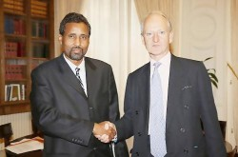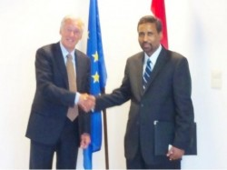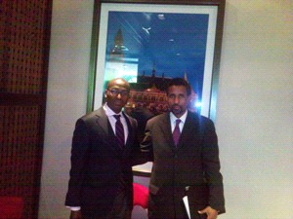

The Puntland State Minister for Planning and International Cooperation Prof. Abdulkadir Abdi Hashi concluded a four- day visit to the Netherlands and the United Kingdom of Great Britain and Northern Ireland where he held talks with senior Ministers from the governments of the Netherlands and the United Kingdom respectively following official invitations he received from the two countries.
On Tuesday May 10, 2011, Minister Hashi held talks with the Dutch Minister for European Affairs and International Cooperation Mr. Ben Knapen who received him in his office at the Ministry of Foreign Affairs in the Hague. Two days later, on 12 May, 2011, Minister Hashi also met at the Foreign and Commonwealth Office in London with the British Minister for Africa and the United Nations Mr. Henry Bellingham. Minister Hashi briefed his hosts on the important developmental milestones the government of Puntland reached and the role Holland and the UK can play in assisting Puntland to consolidate the gains it made in the areas of security, socio-economic development, livelihoods and democratization. The two sides also discussed piracy off the coast of Somalia and particularly that of Puntland, the threat it poses to the free flow of international commerce, and the need to combat this scourge together. Minister Hashi appealed to the Ministers to assist Puntland to make its already highly successful counterpiracy efforts even more effective by raising Puntland’s enforcement and prosecutorial capacity to international standards so us to make it strong enough to effectively deal with the threat. Both Ministers congratulated Puntland for the great leaps forward it has taken since its inception and particularly during the Farole administration and pledged to extend all necessary support to Puntland.
On Somalia the Minister shared with the two governments Puntland’s known positions on ending the transition and restoring the Somalia Republic. He asked the UK and the Netherlands to assist the Somali people to achieve that goal soon by supporting the Special Representative of the UN Secretary General to Somalia Dr. Augustine Mahiga’s efforts to that end. Finally, Minister Hashi welcomed the British government’s decision to reopen the UK Embassy in Somalia as soon as the progress on the ground merited it.

